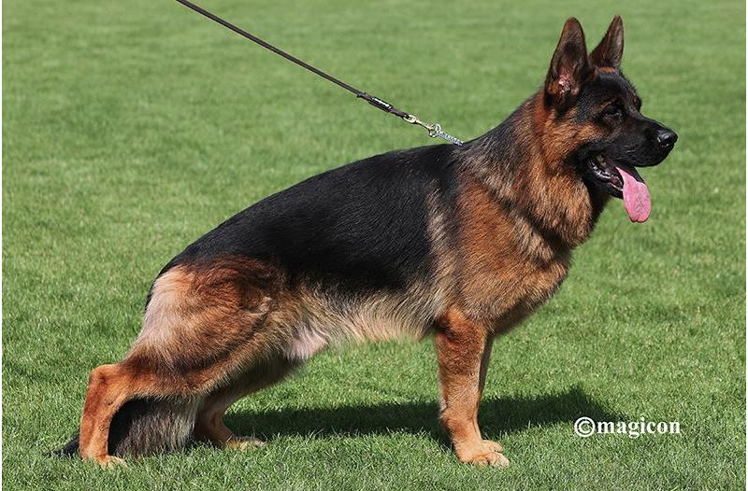
My name is Team Hühnegrab, SZ 2365196, IGP3,IFH1,ZAP
Date of birth: 08.04.2020 (Usher aus der Brunnenstrasse, SZ 2344020,IGP3,IFH2,ZAP.
Zhira vom Hühnegrab ,SZ 2334712, IPO1.
Inbreeding: Vegas Haut Mansard (5.5 -5) Zamp Thermodos (5-5.5.5) Opus Radhaus
(3-) Omen Radhaus (-3).
Normal HD, DNA checked, almost normal ED, HD Zuchtwert 83, Zuchtwert size 101 (97.69%) (64.5 cm).

The world Sieger of the year 2025 is large, strong and substantial, with very good anatomical proportions, dry and firm, expressive, with very good pigmentation.
It has a very strong and very well formed head, dark eyes, firm ears, high withers, firm back, rump of good size and position, correct front and rear angulations, balanced thoracic proportions, straight front, feet straight in front, and almost straight in back.
It develops a very vigorous movement, covering a lot of ground, always with a very good presentation.
Mio has achieved a high level of maturity, presenting himself to the competition in optimal shape. He presents his third group of progeny, which in terms of the number and quality of its specimens, left a very good impression. Some of his sons achieved high positions, even in the working class, and the Sieger class of very young short-haired males. Mio, as the son of Sieger Usher aus der Brunnenstrasse, and through his mother, Zhira Hühnegrab, his grandmother Gamba and his great-grandmother Jalmari, comes from very established lines. Test of courage, well above average, TSB notorious, loose.

